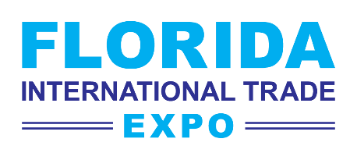
www.floridaexpo.com
REGISTER NOW
FOR FREE
A Multi-Sector Virtual Showcase of Florida's
Leading Products and Services

Enterprise Florida, Inc. (EFI), the official economic and trade development agency for the State of Florida, USA is pleased to present the first-ever Florida International Trade Expo, a virtual showcase of 150+ of the state’s leading products and services providers.

Who Should Attend?
Agents, distributors, buyers, representatives, and wholesalers seeking high-quality products for distribution and sale in Europe, Latin America and the Caribbean, Canada, Mexico, Africa, Asia, and the Middle East.

Benefits of Participating
- Connect with Florida exhibitors in a wide range of industries
- Text and video chat directly with Florida company representatives
- Arrange virtual business meetings during the expo
- View live webinars with Florida industry leaders and other experts
- Engage with a network of Florida professionals who can help buyers and sellers connect
Expo Industry Sectors

The Florida International Trade Expo will connect you with decision makers from a wide variety of industries.

- Automotive  - Aviation & Aerospace  - Building Products  - Clean Technology  - Consumer Goods  - Educational Institutions | - Financial & Professional Services  - Fire & Safety  - Food Products  - Government Agencies  - Health & Beauty  - Industrial Equipment & Supplies | - Information Technology  - Life Sciences & Medical Technology  - Logistics, Distribution & Infrastructure  - Marine Equipment & Boats  - Seaports  - And More!
Contact Information

For further information about the Florida International Trade Expo, please email floridaexpo@enterpriseflorida.com.

